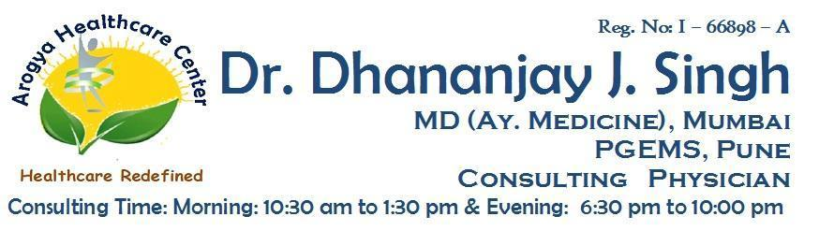 

**Patient’s Name :** **Gender/Age :** M / F / Yr/Mo **Date :** /07/2021

**K/C/O :** HTN / IHD / DM / BA / COPD / KOCHS / RA / NONE

HYPO / HYPER THYROIDISM - ON Rx / NOT ON Rx

**Drug Allergies :** NONE /

**Present Complaints :**

**Rx**

BP: __________mmHg

P : ___________/ min

T : ____________F

SPO2 : __________%

Advice :

Follow Up After : Dr Dhananjay J Singh

**Note :**

1. Please bring this paper on every visit. 3. Don’t substitute any medicine without consultation.
2. This prescription cannot be used for medico-legal purposes. 4. Please confirm medicines with the doctor before use.

**Address :** Shop No:3, Rosewood Building, Orchid Residency, Charnipada, Bhiwandi, Thane M: +91 9762 266 021